**Assignment 1 – Report**

Group members: Caiwei He(caiweih2), Chengrui Zhu, Kelong Wu

**Part 1.1**

1. DFS

Medium maze:

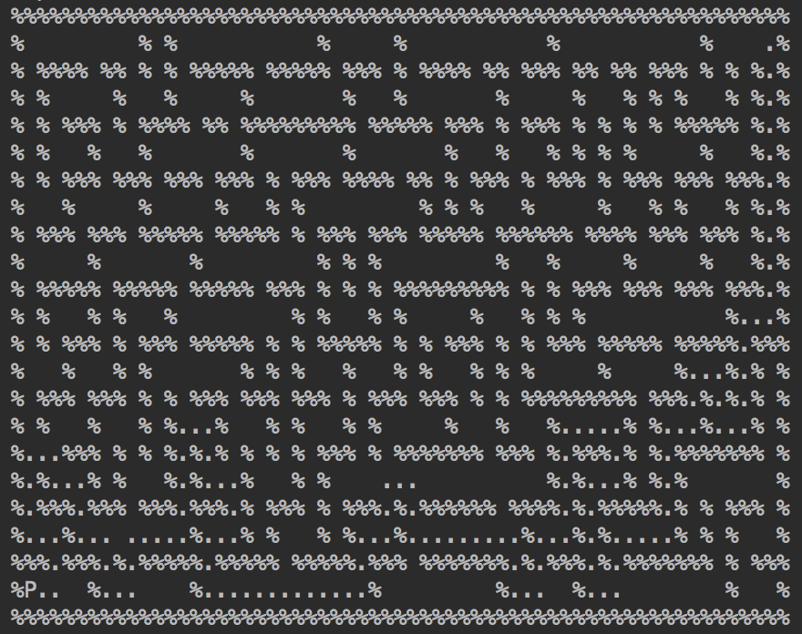

Big maze:

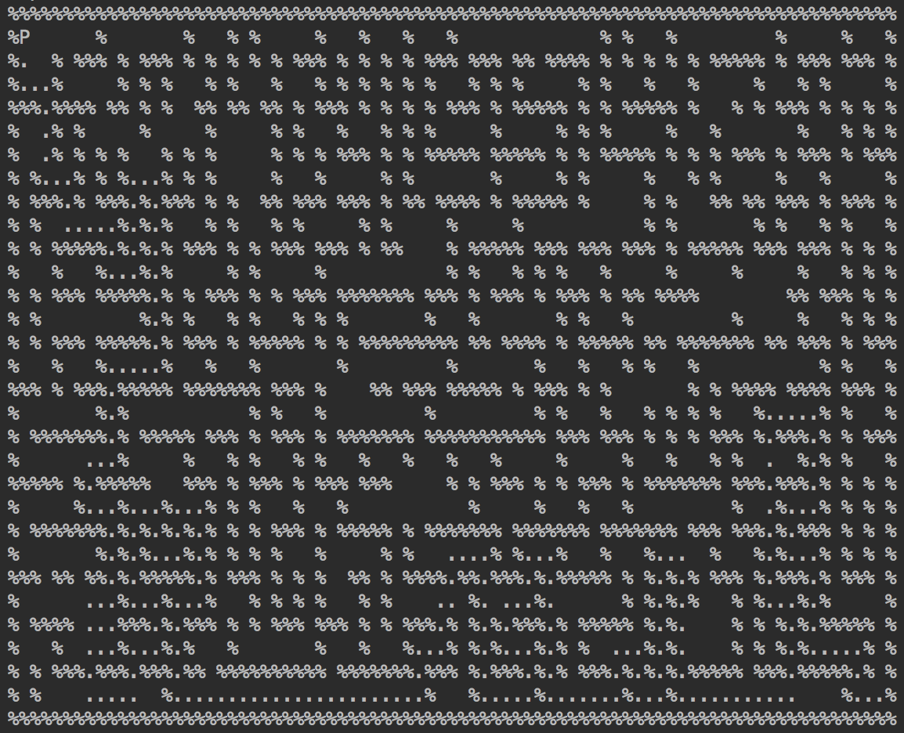

Open maze:

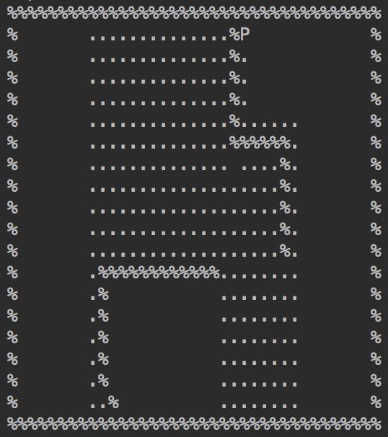

1. BFS

Medium maze:

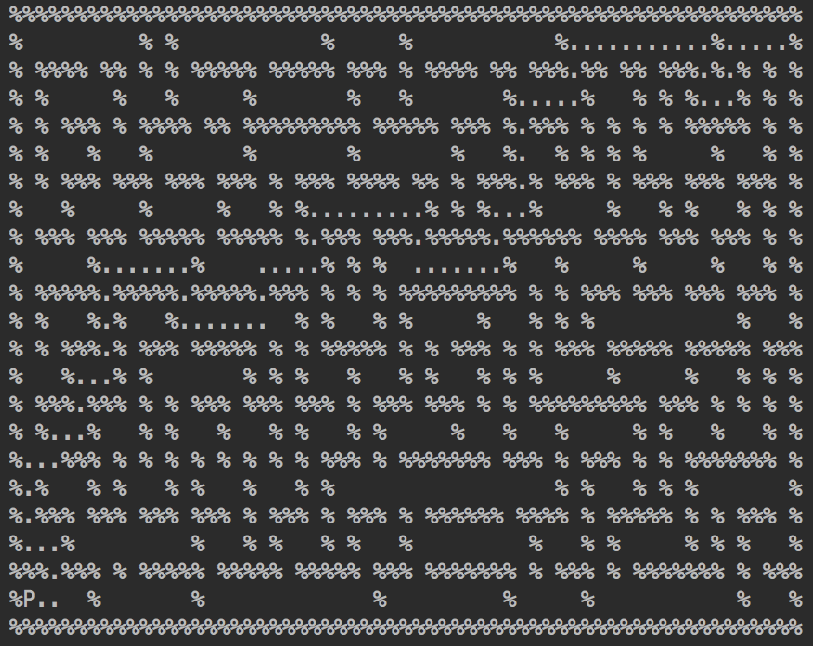

Big maze:

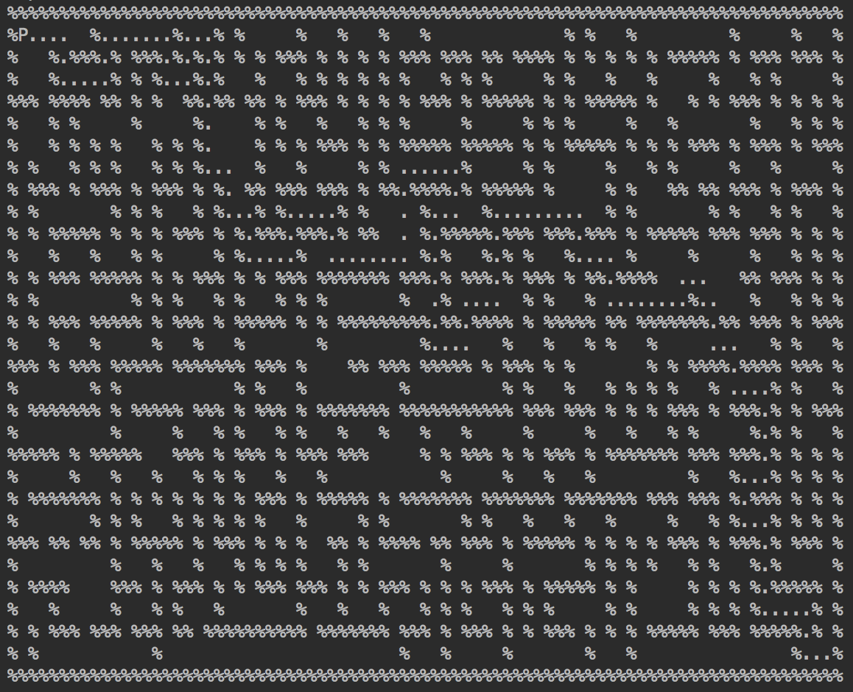

Open maze:

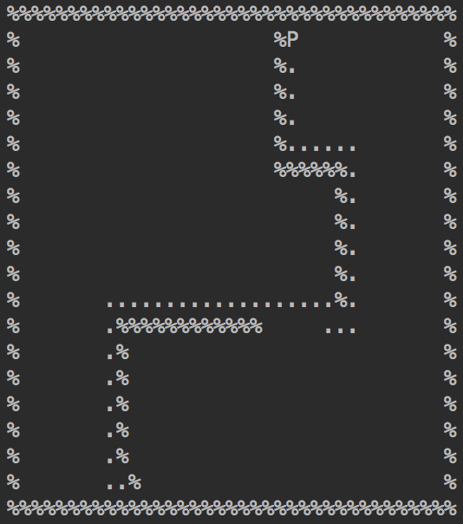

1. Greedy BFS

Medium maze:

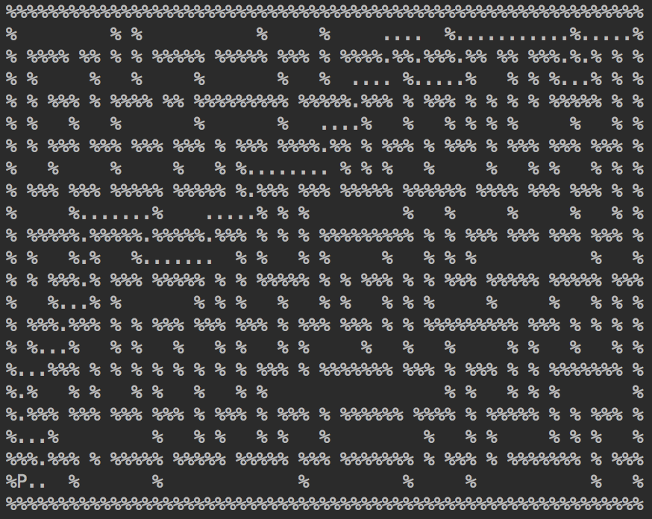

Big maze:

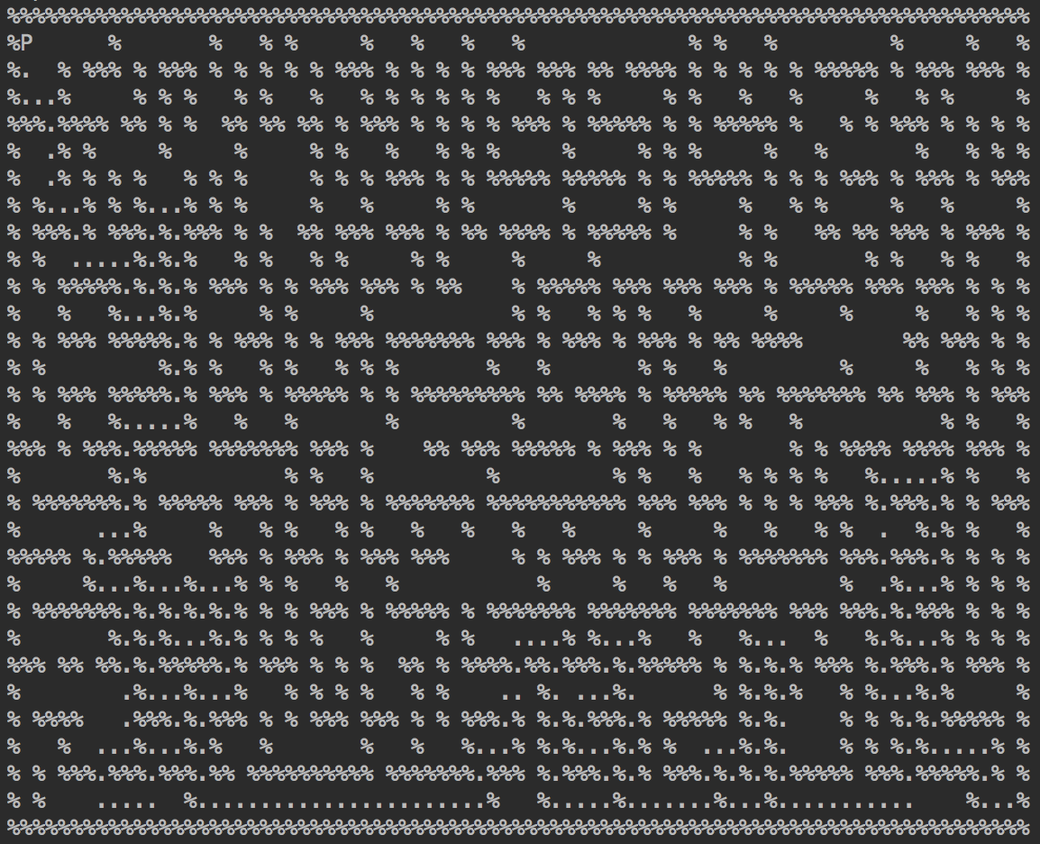

Open maze:

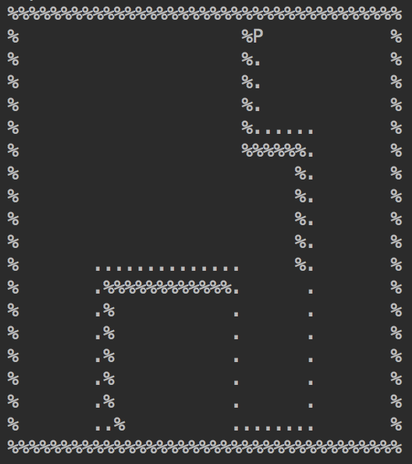

1. A*

Medium maze:

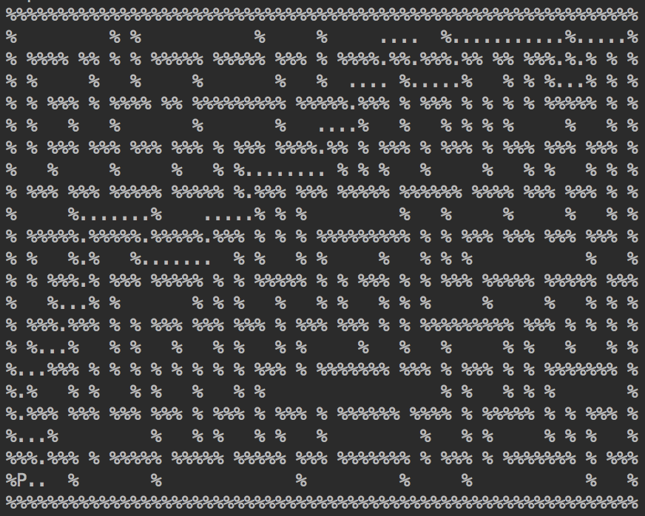

Big maze:

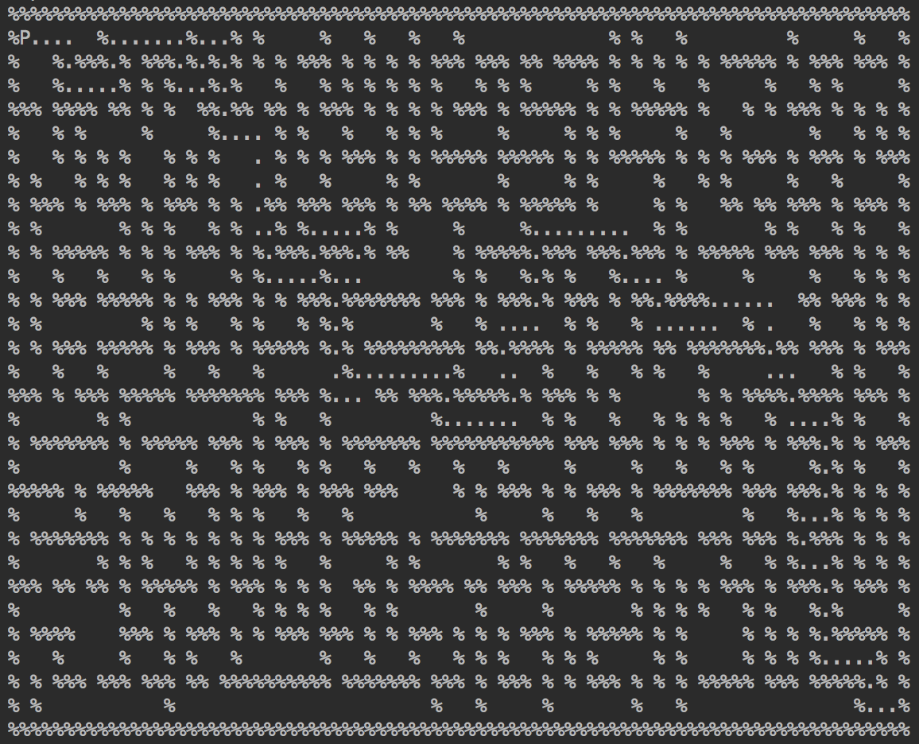

Open maze:

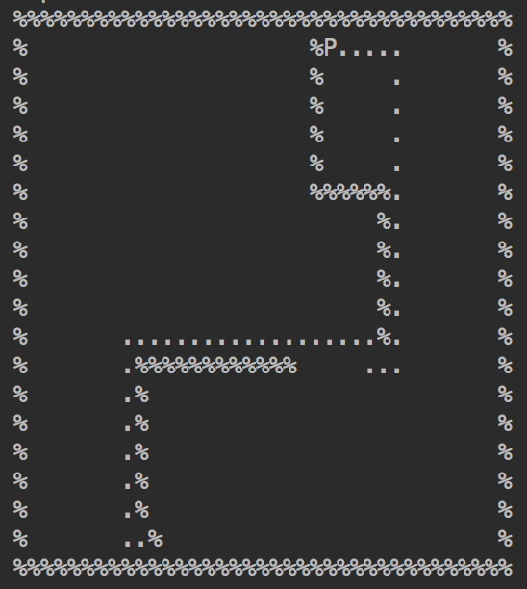

Path cost & Expanded nodes:

|  |  |  |  |  |
| --- | --- | --- | --- | --- |
| (cost/expanded) | DFS | BFS | Greedy BFS | A* |
| Medium | 137/186 | 94/614 | 94/102 | 94/334 |
| Big | 239/255 | 148/1258 | 234/290 | 148/1112 |
| Open | 258/404 | 45/538 | 57/154 | 45/237 |

Analysis:

In all, A* performs the best, then BFS, Greedy, and DFS performs the poorest. A* always focuses on the best solution with regard to the heuristic function which is the Manhattan distance to the goal and the current cost, while greedy only focuses on the heuristic function. BFS searches through each layer while DFS sticks with one path and another if the previous one doesn’t work.

The order to find children of each node is down, right, up, and left. Changing the order only makes a big difference in DFS, because DFS sticks with one leaf first, and others if previous leaf does not return the result.